class profile::accounts::n_denisov inherits profile::accounts::params {

group {'n.denisov':
ensure => 'absent',
gid => '4826',
}

user {'n.denisov':
ensure => 'absent',
comment => 'Denisov Nikolay Alekseevich',
gid => '4826',
home => '/home/n.denisov',
password => '****',
groups => $admningroup,
managehome => no,
shell => '/bin/bash',
uid => '4826',
require => Group['n.denisov'],
}
}

https://vm-gitlab01.tcsbank.ru/Puppet/control/merge_requests/2672/diffs

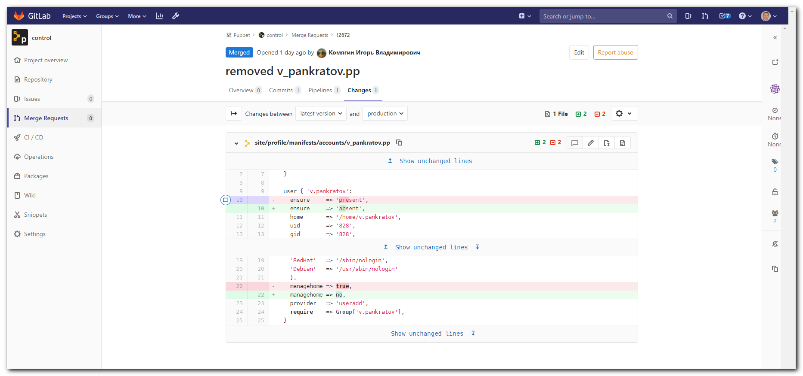

site/profile/manifests/accounts/v_pankratov.pp

Show unchanged lines
}

user { 'v.pankratov':
ensure => 'present',
ensure => 'absent',
home => '/home/v.pankratov',
uid => '828',
gid => '828',
Show unchanged lines
'RedHat' => '/sbin/nologin',
'Debian' => '/usr/sbin/nologin'
},
managehome => true,
managehome => no,
provider => 'useradd',
require => Group['v.pankratov'],
}

